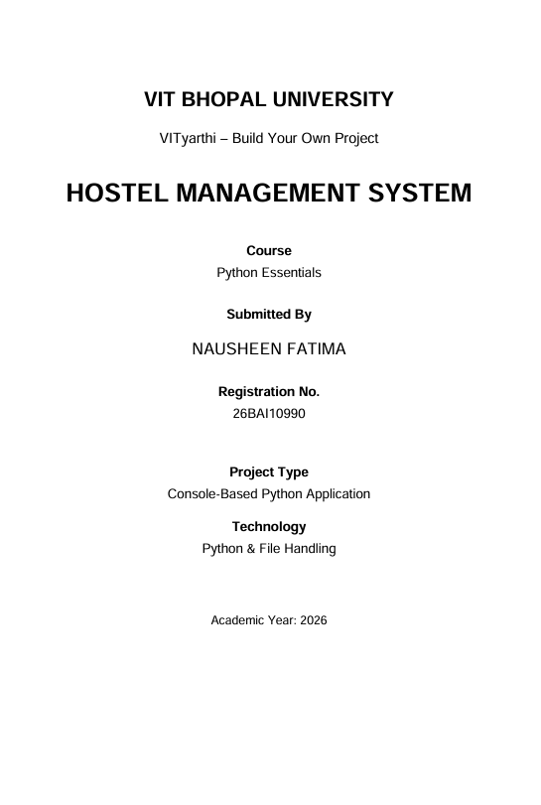

- INTRODUCTION
The Hostel Management System is a console-based Python application developed as part of the VITyarthi – Build Your Own Project for the Python Essentials course.
The project is designed to manage common hostel activities in an organized manner. It provides separate modules for student management, room management, fee management, complaint management, attendance management, and report generation.
The system uses Python file handling to store and retrieve information through text files. It also includes input validation and error handling to improve reliability and prevent invalid data from being processed.
The project follows a modular structure, with different Python files responsible for different functions of the system. This demonstrates the practical application of Python programming concepts, file handling, modular programming, validation, and testing.
The main objective of the project is to provide a simple computerized approach to basic hostel record management while demonstrating the concepts learned in the Python Essentials course.

2. PROBLEM STATEMENT
Managing hostel records manually can be time-consuming and difficult to organize. Important information such as student details, room allocation, fee payments, complaints, and attendance may be maintained separately, making it difficult to access and update records efficiently.
The Hostel Management System aims to provide a simple computerized solution for managing these basic hostel activities. The system allows hostel staff to maintain student and room records, record fee payments, manage complaints, record attendance, and generate a summary report.
The application is developed using Python and file handling, with separate modules for different hostel operations. Input validation and error handling are also included to improve the reliability of the system.

3.FUNCTIONAL REQUIREMENTS
3.1 Student Management
The system shall allow the user to:
- Add student details.
- View student records.
- Search for a student using the student ID.
- Validate student ID, age, and room number.
Input: Student ID, name, age, course, room number
Output: Student record or appropriate validation/error message.
3.2 Room Management
The system shall allow the user to:
- Add rooms.
- View room records.
- Allocate a room to a student.
- Vacate an allocated room.
- Check room availability.
Input: Room number, capacity, student ID where required
Output: Updated room status or appropriate error message.
3.3 Fee Management
The system shall allow the user to:
- Record fee payments.
- View fee records.
- Validate the student ID and payment amount.
Input: Student ID, amount, month
Output: Fee payment record or validation/error message.
3.4 Complaint Management
The system shall allow the user to:
- Register complaints.
- View complaints.
- Resolve pending complaints.
Input: Student ID and complaint description
Output: Complaint record with its current status.
3.5 Attendance Management
The system shall allow the user to:
- Mark student attendance.
- View attendance records.
Input: Student ID, date, attendance status
Output: Attendance record.
3.6 Report Generation
The system shall allow the user to generate a hostel summary containing:
- Total students.
- Total rooms.
- Available rooms.
- Allocated rooms.
- Pending complaints.
- Resolved complaints.
Input: User's report selection
Output: Hostel summary report.
WORKFLOW
User
↓
Main Menu
↓
Select Module
↓
Enter Input
↓
Validate Input
↓
Process Data
↓
Store/Retrieve Text File
↓
Display Output

4. NON-FUNCTIONAL REQUIREMENTS
4.1 Usability
The system should provide a simple and understandable console-based interface. Users should be able to navigate between different hostel management modules through the main menu.
4.2 Reliability
The system should correctly store and retrieve hostel records using text files. It should also handle missing data files without unexpectedly terminating the application.
4.3 Maintainability
The application is divided into separate modules such as student.py, room.py, fees.py, complaints.py, attendance.py, reports.py, and validation.py. This modular structure makes the project easier to understand and maintain.
4.4 Error Handling
The system should validate important user inputs and display suitable error messages when invalid information is entered or required files are unavailable.
4.5 Resource Efficiency
The application uses simple Python file handling and does not require a database server or other external services.

5. SYSTEM ARCHITECTURE
The Hostel Management System follows a modular console-based architecture. The user interacts with the system through main.py, which provides the main menu and connects the different functional modules.
5.1 Architecture Components
- main.py — Controls the main menu and navigation.
- student.py — Handles student records.
- room.py — Handles room creation, allocation, and vacation.
- fees.py — Handles fee payment records.
- complaints.py — Handles complaint registration and resolution.
- attendance.py — Handles attendance records.
- reports.py — Generates the hostel summary report.
- validation.py — Performs input validation.
- data/ — Contains the text files used for persistent data storage.

5.2 Architecture Flow
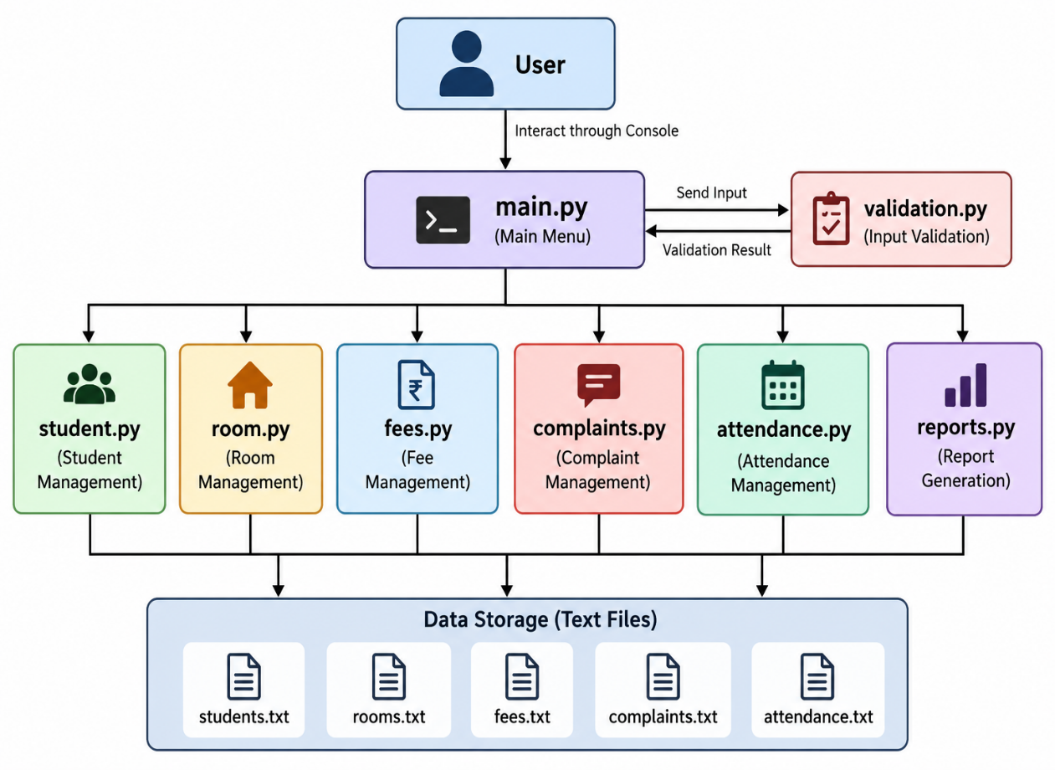

5.3 Data Storage
data/
├── students.txt
├── rooms.txt
├── fees.txt
├── complaints.txt
└── attendance.txt

6. DESIGN DRAGRAMS

6.1 System Architecture
User
↓
main.py
↓
Student | Room | Fees | Complaints | Attendance | Reports
↓
data/*.txt
The Hostel Management System follows a modular console-based architecture. The user interacts with the system through main.py, which provides the main menu and connects the different functional modules. The Student, Room, Fee, Complaint, Attendance, and Reports modules handle their respective operations. The validation.py module performs input validation, while the text files in the data/ folder provide persistent storage for the system records.

6.2 Workflow Diagram
Start
↓
Main Menu
↓
Select Module
↓
Enter Input
↓
Validate Input
↓
Process Request
↓
Store/Retrieve Data
↓
Display Result
↓
Main Menu / Exit
The workflow begins when the user starts the application and reaches the main menu. The user selects a required module and enters the necessary information. The system validates the input where applicable. If the input is invalid, an error message is displayed. If the input is valid, the requested operation is performed and the required data is stored or retrieved from the appropriate text file. The result is then displayed to the user, who can return to the main menu or exit the application.

6.3 Use Case Diagram

```text
+--------------------------------------+
| HOSTEL MANAGEMENT SYSTEM |
| |
| +-------------------------------+ |
| | Student Management | |
| | - Add Student | |
| | - View Students | |
| | - Search Student | |
| +-------------------------------+ |
| |
| +-------------------------------+ |
| | Room Management | |
| | - Add Room | |
| | - View Rooms | |
| | - Allocate Room | |
| | - Vacate Room | |
| +-------------------------------+ |
| |
| +-------------------------------+ |
| | Fee Management | |
| | - Add Fee Payment | |
| | - View Fee Records | |
| +-------------------------------+ |
| |
| +-------------------------------+ |
| | Complaint Management | |
| | - Register Complaint | |
| | - View Complaints | |
| | - Resolve Complaint | |
| +-------------------------------+ |
| |
| +-------------------------------+ |
| | Attendance Management | |
| | - Mark Attendance | |
| | - View Attendance | |
| +-------------------------------+ |
| |
| +-------------------------------+ |
| | Reports | |
| | - View Hostel Summary | |
| +-------------------------------+ |
+--------------------------------------+
^
|
|
+----------------+
| Hostel Staff / |
| Administrator |

The Use Case Diagram represents the interaction between the Hostel Staff/Administrator and the Hostel Management System. The user can perform student management, room management, fee management, complaint management, attendance management, and report generation. The diagram identifies the major functions available to the system user.

6.4 Class/ Component diagram
main.py
├── student.py
├── room.py
├── fees.py
├── complaints.py
├── attendance.py
├── reports.py
└── validation.py
↓
data/*.txt
The Class/Component Diagram represents the modular structure of the application. main.py acts as the central entry point and connects the different components. The modules student.py, room.py, fees.py, complaints.py, attendance.py, and reports.py handle separate hostel operations. The validation.py component provides input validation, while the modules interact with the text files stored in the data/ folder.

6.5 Sequence Diagram
User
↓
main.py
↓
student.py
↓
validation.py
↓
students.txt

The Sequence Diagram demonstrates the sequence of operations involved in registering a student. The user first selects Student Management and the Add Student option. main.py invokes the student management function. The student's information is collected and passed through the validation functions. After successful validation, the student record is stored in students.txt, and a success message is displayed to the user.

6.6 Storage Design

data/
├── students.txt
├── rooms.txt
├── fees.txt
├── complaints.txt
└── attendance.txt
The Storage Design describes how the Hostel Management System stores its information. The application uses text files located inside the data/ folder. Separate files are maintained for students, rooms, fees, complaints, and attendance. Records are stored in a comma-separated format. Python file handling operations are used to add, read, and update records. Since the current project does not use a relational database, a text-file storage design is used instead.
7. DESIGN DECISIONS & RATIONALE
7.1 Choice of Python
Python was selected because it is the programming language used for the Python Essentials course. It provides simple syntax and supports modular programming, file handling, functions, validation, and testing.
7.2 Choice of Console-Based Interface
A console-based interface was selected to keep the project focused on the core Python programming concepts covered in the course. It provides a simple way for users to interact with the different hostel management modules.
7.3 Choice of File Handling
Text-file storage was selected instead of a database for the current version of the project. It demonstrates Python file-handling concepts while providing persistent storage for student, room, fee, complaint, and attendance records.
7.4 Modular Design
The application is divided into separate Python modules according to their responsibilities. For example, student operations are handled by student.py, room operations by room.py, and validation by validation.py.
This makes the code easier to understand, test, and maintain.
7.5 Input Validation
Input validation was included to prevent common invalid inputs from being accepted. Validation is applied to important fields such as student ID, age, fee amount, and room number.
7.6 Error Handling
File operations include error handling for situations such as missing data files. The system also displays appropriate messages when invalid menu choices or input values are provided.
7.7 Testing
A separate validation test file was included to test important validation functions. This provides a basic way of checking whether the validation logic behaves as expected.
7.8 Version Control
Git is used for version control so that changes to the project can be tracked and the completed project can be maintained in a GitHub repository.

8. IMPLEMENTATION DETAILS
The Hostel Management System is implemented using Python with a modular structure. Each major hostel operation is handled by a separate Python module, while text files are used for persistent data storage.
8.1 Main Menu
The main.py module provides the main menu and connects the different modules of the application.
The user can select:
- Student Management
- Room Management
- Fee Management
- Complaint Management
- Attendance Management
- Reports
- Exit
8.2 Student Management
The student.py module manages student records.
It provides functions to:
- Add students
- View students
- Search students
Student information is stored in students.txt.
8.3 Room Management
The room.py module manages hostel rooms.
It provides functions to:
- Add rooms
- View rooms
- Allocate rooms
- Vacate rooms
Room information and room status are stored in rooms.txt.
8.4 Fee Management
The fees.py module manages fee payment records.
It allows the user to:
- Record fee payments
- View fee records
The records are stored in fees.txt.
8.5 Complaint Management
The complaints.py module handles hostel complaints.
It allows users to:
- Register complaints
- View complaints
- Resolve pending complaints
Complaint information is stored in complaints.txt.
8.6 Attendance Management
The attendance.py module manages attendance records.
It allows the user to:
- Mark attendance
- View attendance records
Attendance information is stored in attendance.txt.
8.7 Reports
The reports.py module generates a hostel summary report.
The report provides:
- Total students
- Total rooms
- Available rooms
- Allocated rooms
- Pending complaints
- Resolved complaints
8.8 Validation
The validation.py module contains validation functions for important inputs such as:
- Student ID
- Age
- Fee amount
- Room number
Invalid inputs are rejected and an appropriate message is displayed.
8.9 File Handling
The application uses Python file-handling operations to manage persistent records.
The main operations are:
- Append (a) — adds new records.
- Read (r) — retrieves existing records.
- Write (w) — updates records.
The data is stored in the data/ directory.
8.10 Testing
The project includes tests/test_validation.py, which tests the validation functions for student ID, age, fee amount, and room number.
The validation tests were executed successfully, confirming that the implemented validation functions produce the expected results.

9. SCREENSHOTS/RESULTS

SOURCE CODE OF MAIN.PY
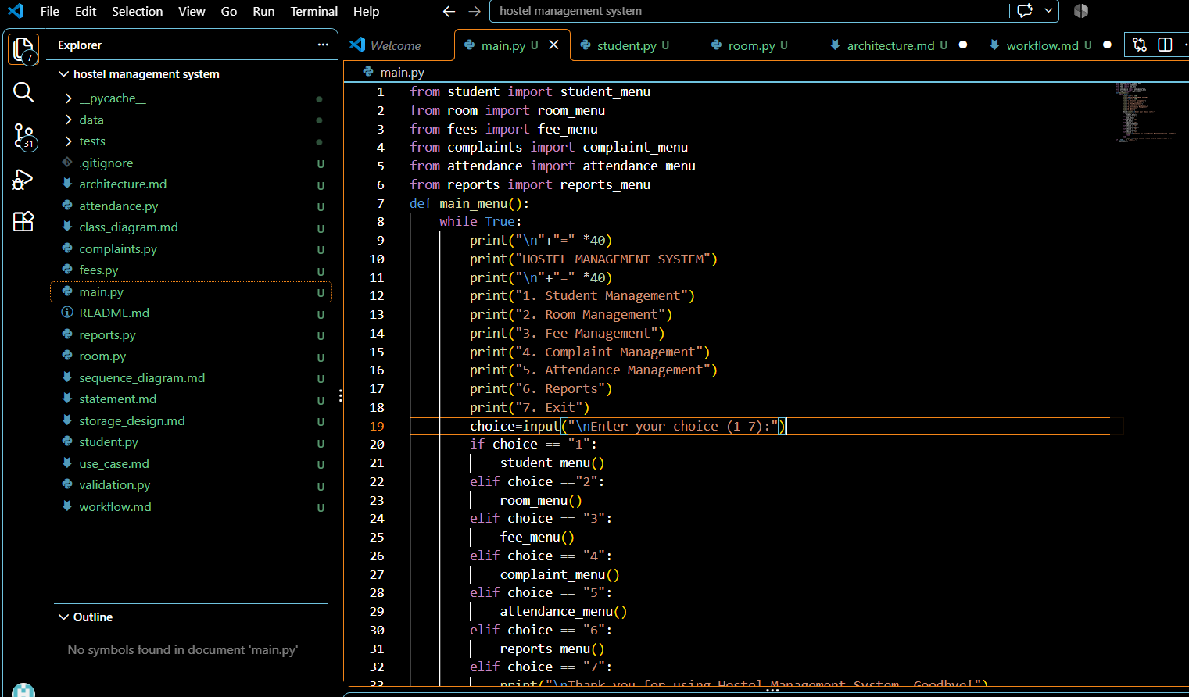
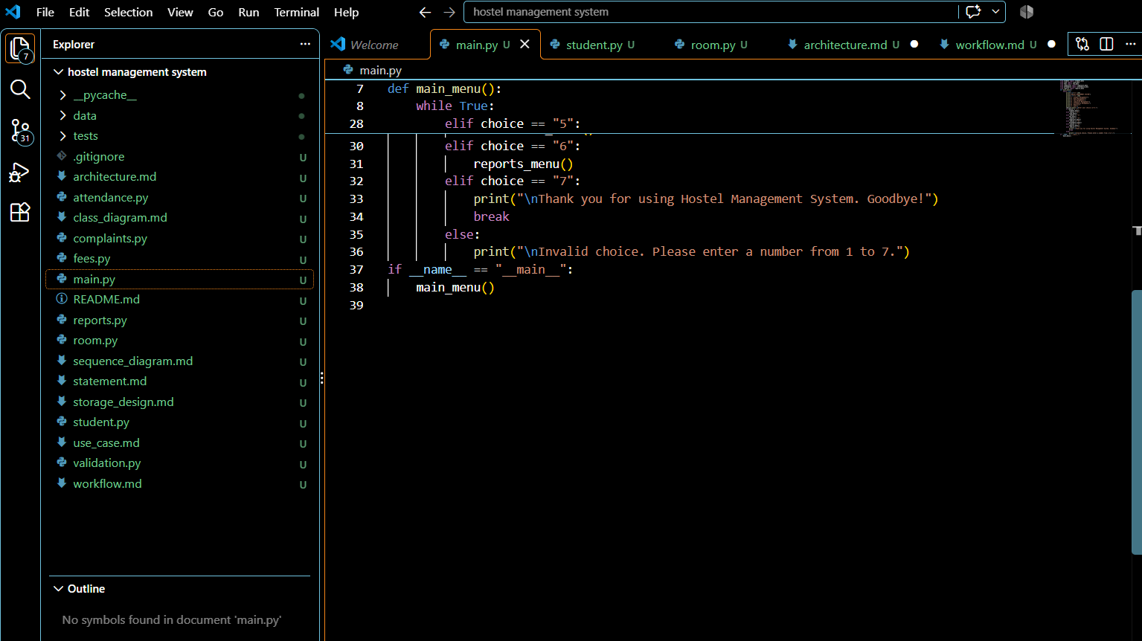

Results:
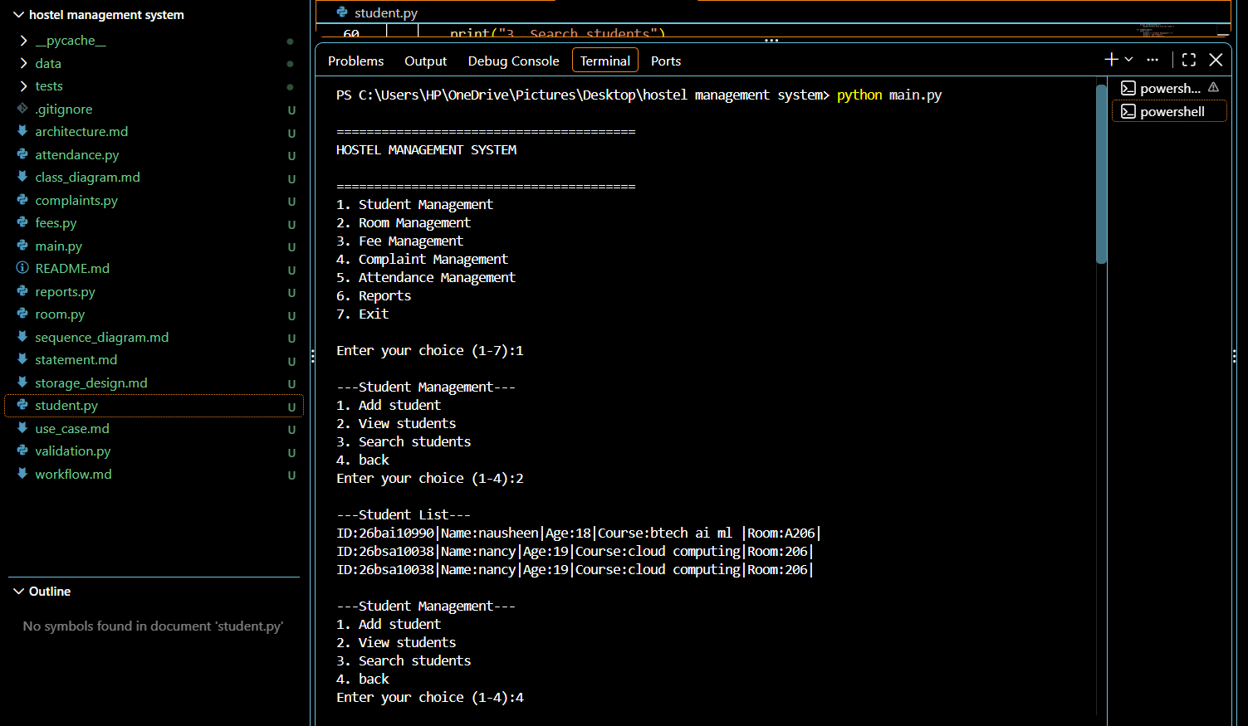
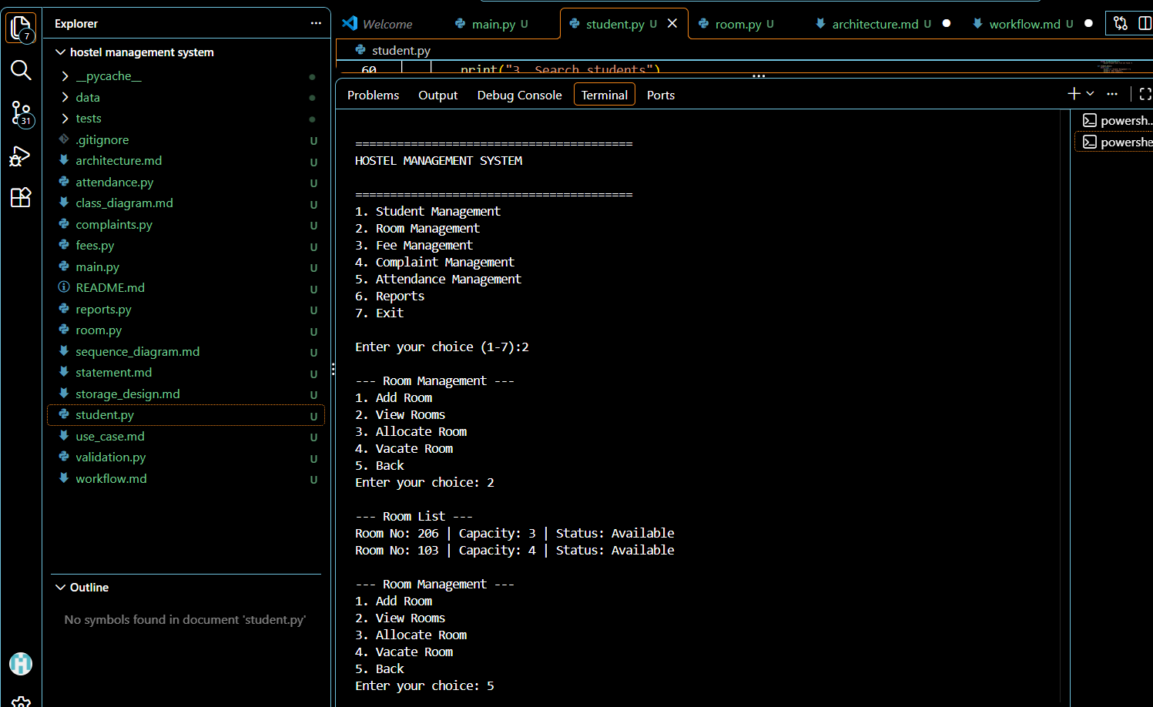

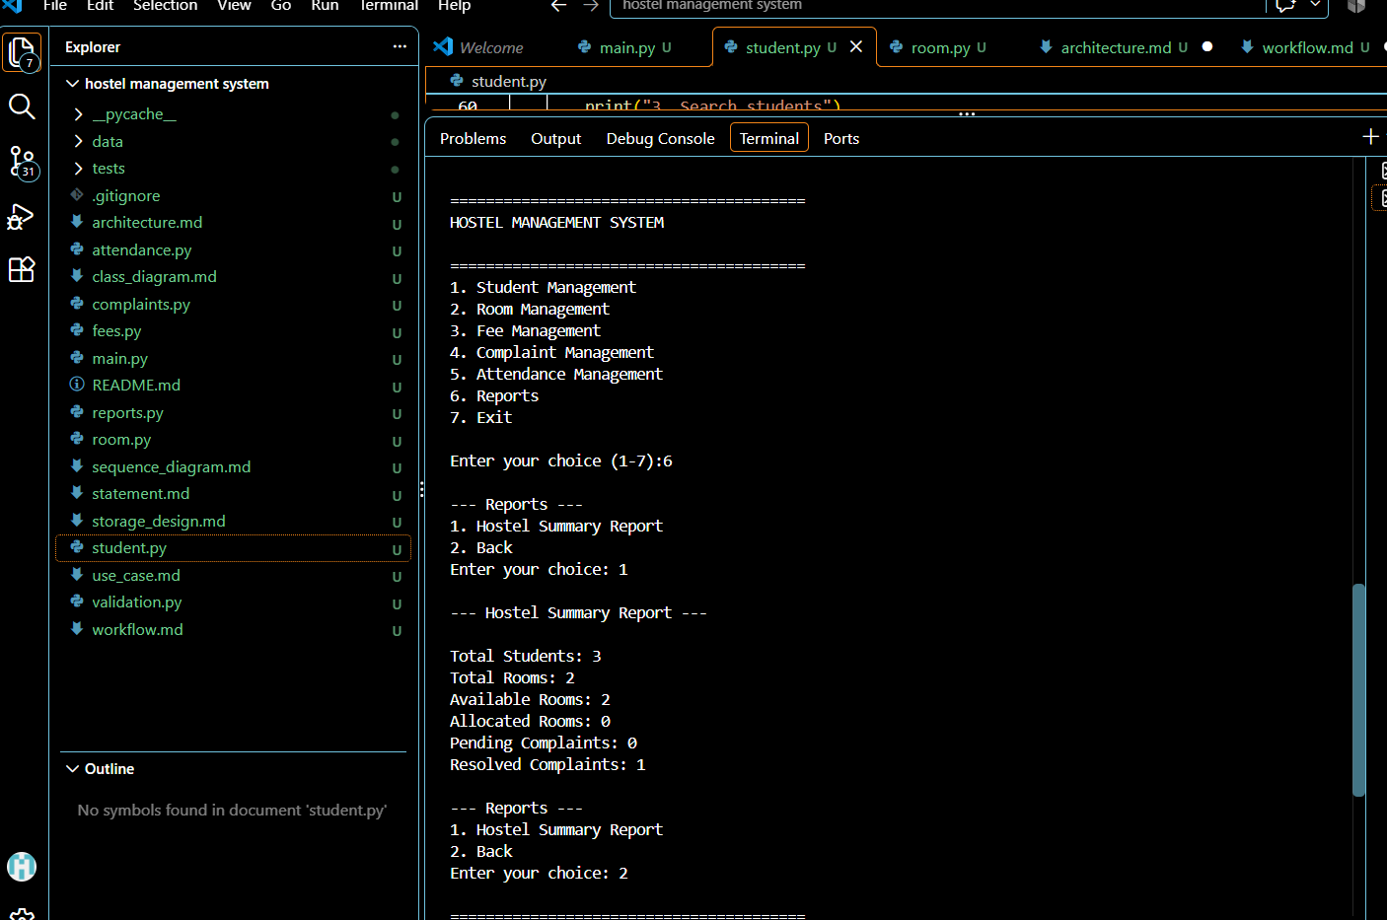
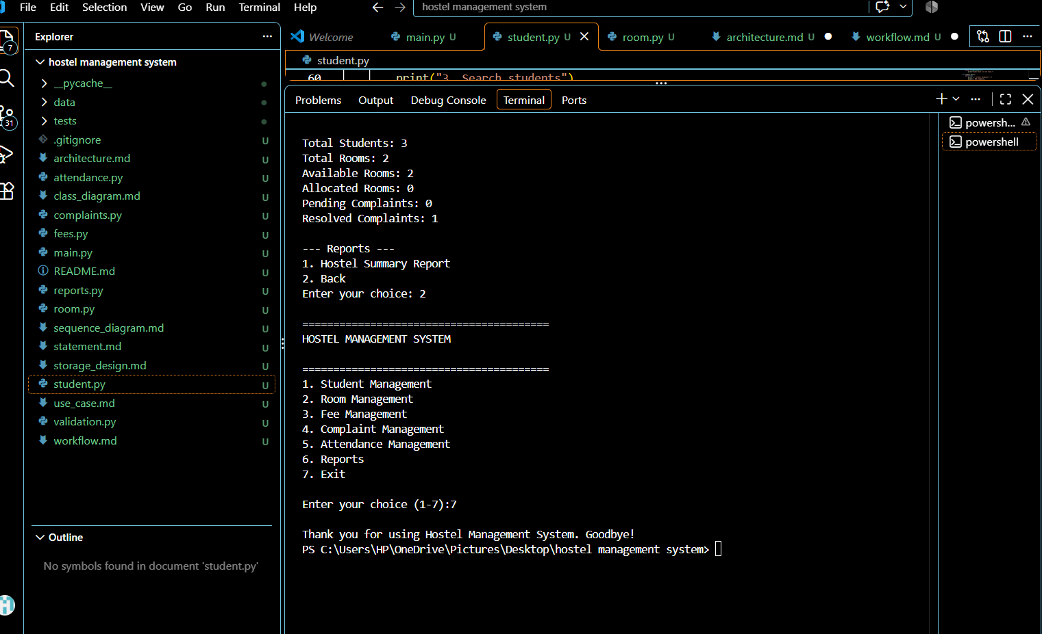

10. TESTING APPROACH
The Hostel Management System was tested to verify that its main modules, input validation, file handling, and error handling work as expected.
10.1 Functional Testing
The major functional modules were tested individually:
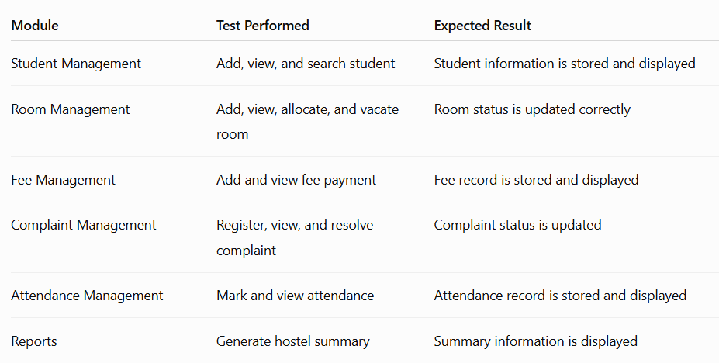
10.2 Validation Testing
The validation functions were tested for:
- Student ID
- Age
- Fee amount
- Room number
The test file tests/test_validation.py was executed using:
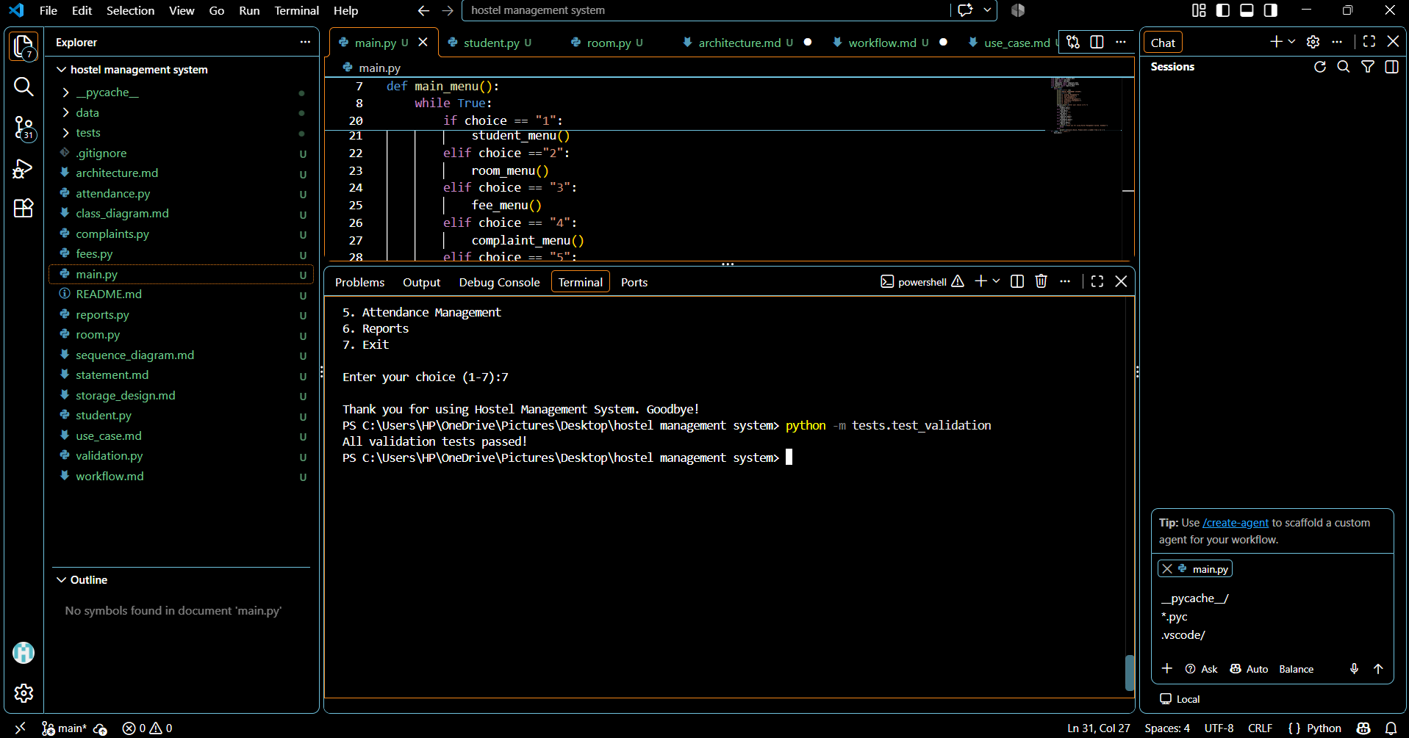
10.3 Error Handling Testing
Invalid inputs were also tested. For example:
- Invalid age
- Invalid fee amount
- Empty room number
- Invalid menu choices
- Missing data files
The system displays appropriate error messages instead of accepting invalid input or terminating unexpectedly.
10.4 Test Result
The main application modules were tested through the console, and the validation tests were executed successfully. The results demonstrate that the implemented functionality and validation logic are working as intended.

11. CHALLENGES FACED
11.1 Managing Multiple Modules
One challenge was dividing the project into separate modules while ensuring that all modules were correctly connected through the main menu.
11.2 File Handling
Working with multiple text files required careful handling of reading, writing, and updating records. The project also needed to handle situations where a required file was not available.
11.3 Input Validation
Another challenge was ensuring that invalid user input was not accepted. Validation functions were created for student ID, age, fee amount, and room number.
11.4 Updating Records
Operations such as room allocation, room vacation, and complaint resolution required existing file records to be read, modified, and written back to the file.
11.5 Testing and Debugging
During development, syntax, indentation, and module-related errors had to be identified and corrected. The validation test module was also used to verify that the validation functions worked correctly.
11.6 Documentation
Another challenge was documenting the project structure, architecture, workflow, UML diagrams, storage design, implementation, and testing results in a systematic manner.

12. LEARNINGS & KEY TAKEAWAYS
12.1 Python Programming
The project provided practical experience in applying Python programming concepts to a real-world problem. It helped demonstrate the use of functions, conditional statements, loops, modules, and user input.
12.2 File Handling
A major learning from the project was using Python file handling to store, read, and update persistent data using text files.
12.3 Modular Programming
The project demonstrated how a larger application can be divided into smaller modules based on their responsibilities. This made the code more organized and easier to maintain.
12.4 Input Validation and Error Handling
The project provided experience in validating user input and handling errors such as invalid values and missing data files.
12.5 Testing
The project demonstrated the importance of testing individual validation functions and checking the behavior of the complete application.
12.6 Software Design and Documentation
The project provided practical experience in designing system architecture, workflows, use cases, component relationships, sequence interactions, and storage design.
12.7 Version Control
Using Git introduced the concept of version control and provided experience in preparing the project for a GitHub repository.
Key Takeaway
The project helped connect Python programming concepts with the development of a complete modular application, from problem identification and design through implementation, testing, and documentation.

13. FUTURE ENHANCEMENTS
13.1 Student Record Management
Future versions could include options to edit and delete student records, in addition to the current add, view, and search functions.
13.2 Attendance Analysis
The system could be extended to calculate attendance percentages and provide more detailed attendance reports.
13.3 Advanced Reports
More detailed reports could be added for fees, attendance, rooms, and complaints.
13.4 Improved Validation
Additional validation rules could be introduced to make data entry more robust.
13.5 Graphical User Interface
A graphical user interface could be developed in a future version to make interaction more visual than the current console-based interface.
13.6 Database Integration
The text-file storage system could eventually be replaced or supplemented with a database for handling larger amounts of data.
13.7 Additional Hostel Features
Future versions could include additional hostel-management functionality as the scope of the system expands.

14. REFERENCES
- VITyarthi – Build Your Own Project: General Project Instructions & Submission Guidelines, provided course/project guide, VIT Bhopal University.
- Python Documentation — used as a reference for Python programming and file-handling concepts.
- Git Documentation — used as a reference for version control and Git-based project management.
- GitHub Documentation — used as a reference for repository creation and project hosting.

